North Lincolnshire Council
Daily Event Analysis
21st October 2010

Overview
The Low Santon TEOM measured a daily mean PM₁₀ concentration of 89µg/m³ on Thursday 21st October 2010 exceeding the allowed 50µg/m³ as a daily mean. The Dawes Lane Coke Oven (DLCO) Osiris measured a daily PM₁₀ concentration of 66μg/m³ also exceeding the allowed 50μg/m³ as a daily mean. A check of the data has revealed that the PM₁₀ concentrations were above the 50μg/m³ threshold between 06:00 and 18:00 at the Low Santon TEOM and fluctuated throughout the same period at the DLCO Osiris. The average PM₁₀ concentration for this time period at the Low Santon TEOM was 140μg/m³ and 65μg/m³ at the DLCO Osiris. There was a significant peak in the PM₁₀ concentration at the DLCO Osiris at 13:30 measuring 473μg/m³, this peak will be commented on separately.

Met Conditions
Consistent SW winds were observed throughout the day. The wind within the 4 hour period of focus ranged between 196° and 256°. Wind speeds averaged at 3.0 m/s. No rain was measured throughout the day.

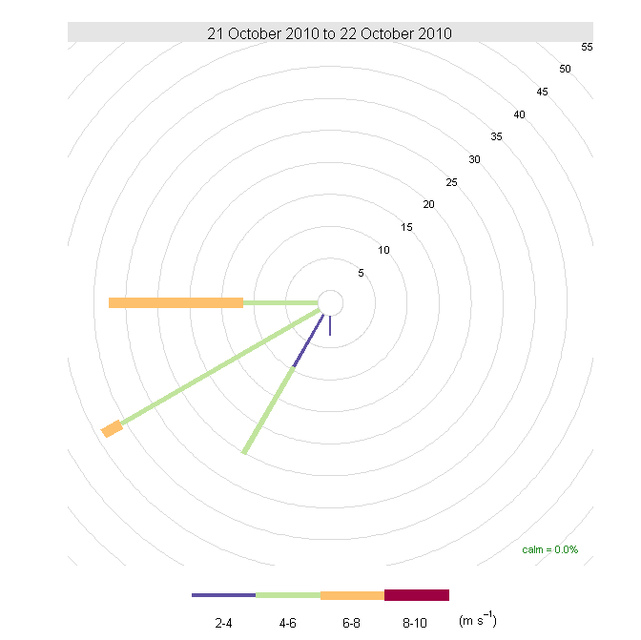

Episode Wind Range 06:00 to 10:00

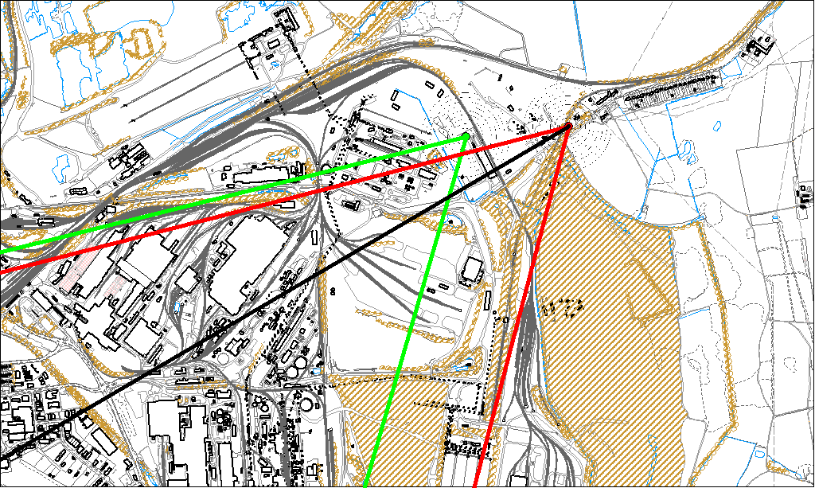

Potential Sources
The above map shows the Low Santon TEOM (indicated by the red lines) and the DLCO Osiris (indicated by the green). The black line within the red shows the wind direction of the highest concentration recorded during the 4 hour period of focus.

As the Low Santon TEOM measured consistently higher concentrations during this period, it is likely that the TEOM was affected by a different source to the DLCO Osiris. The Osiris did exceed the 50μg/m³ threshold for the day. Because of this difference the source areas in which the red and green lines cross over are unlikely to be the location of the problem.

The likely areas include;

- Dawes Lane Coke Ovens
- The Redbourn Steel Stocking Area
- Tarmac
- Slag Haul Road
- Intermediate Site
- Ore Beds

The black line indicates the highest measured concentration of 177μg/m³ recorded at the Low Santon TEOM during this period. It runs through both the Tarmac site and the NW tip of the Redbourn Steel Stocking Area.

Peak at DLCO Osiris

Additionally there was a significant peak in PM₁₀ concentration at the DLCO Osiris which is highlighted on the graph below. This peak occurred at 13:30 and measured 473μg/m³.

13:30 DLCO Osiris

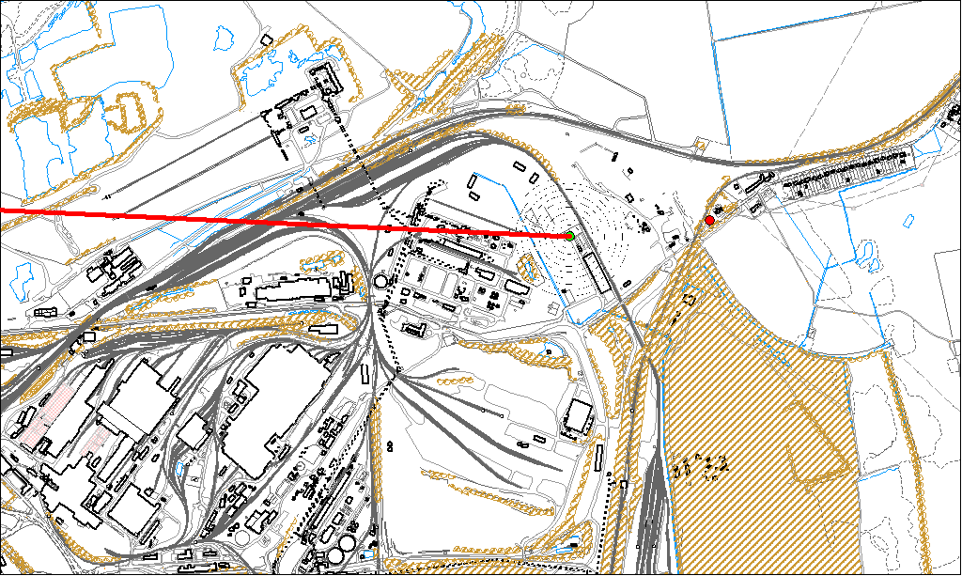

Potential sources

The red line on the above map and the spike on the graph show the highest concentration experienced at the DLCO Osiris. This line runs through the Dawes Lane Coke Ovens Site.

